StratoSolar Photovoltaic system

**Introduction:** The goal of this document is to present a short introduction to StratoSolar Photovoltaic (PV) technology and economics.

Alternative energy solutions are struggling to be economically viable without subsidy and also demonstrate that they can scale adequately without damaging the environment they are allegedly trying to protect.

It is becoming increasingly clear that no current alternative energy technology is in sight of satisfying these two big constraints, and in a world of fiscal austerity the will to subsidize alternative energy solutions to the degree necessary to take them to economic viability is rapidly disappearing.

The StratoSolar PV solution represents an opportunity to make today’s PV technology cost effective without the massive subsidy needed to drive the technology to commercial viability in the 15 to 20 years historical trends would indicate will be necessary. It also makes PV an affordable alternative for locations like Germany and Japan where PV is unlikely to ever be viable without subsidy.

## What the StratoSolar PV system does:

* Weather independent, photovoltaic solar power (PV)
* Locations up to latitude 60 produce market competitive electricity
* Electricity in utility scale systems from 10 MW to 1 GW in modular increments
* Cost competitive electricity without subsidy

## Key insights:

The idea exploits two environmental facts. Firstly, the stratosphere is a permanent inversion layer in the earth’s atmosphere. Inversion layers effectively isolate gas bodies. The calm weather free stratosphere is isolated from the turbulent troposphere below. There is no rain, hail, snow, or moisture in the stratosphere and wind force is much reduced and stable. This means that buoyant platforms suspended in the stratosphere can be permanently stationed there without needing to be winched down in bad weather. It also means that PV panels in the stratosphere don’t suffer water or snow or ice based weather effects and can be simpler and cheaper to manufacture.

Secondly, light from the sun at 20km altitude is both strong and constant from dawn to dusk. At 20km a platform is above over 90% of the atmosphere, so sunlight is not significantly scattered or absorbed and there are no clouds to interrupt power generation. This means that on average PV panels produce multiples of the power they can generate on the ground, and just as important, the power is highly predictable and not subject to interruption by clouds or storms.

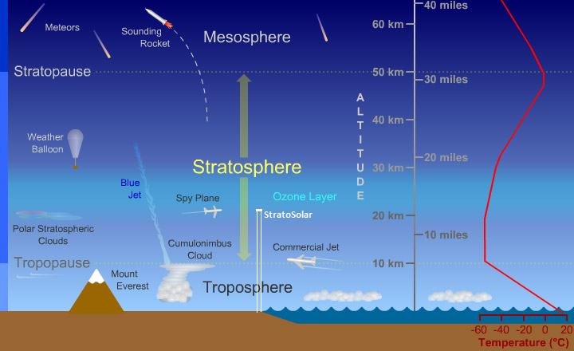

Figure Where StratoSolar fits in the atmosphere

Figure 1 above helps illustrate where a StratoSolar PV system sits in the atmosphere and its relationship to various phenomena at mid latitudes. The PV platform is positioned in the stratosphere at the bottom of the ozone layer where the air temperature is about -55 degrees Celsius.  The cumulonimbus cloud illustrates the relative scale and altitude of a severe super cell thunderstorm, the most violent weather event that affects the tethers in the troposphere. Some super cell thunderstorms can punch through the tropopause and top out close to 20km, and a small percentage spawn tornadoes.  The jet stream, another strong wind phenomenon that affects the tethers is not shown explicitly, but when present it would be positioned just below the tropopause and be a few km thick.

## Why it generates electricity at a reasonable cost:

For solar-power plants, almost the complete operating cost is the loan payment. The StratoSolar PV system has a reasonable operating cost mostly because the solar PV array (which dominates PV cost) has a reasonable capital cost and a high utilization, with a resulting reasonable cost of electricity. The reasons for this are:

* The PV panels are exposed to 1.5 to 3.5X the solar energy of ground-based PV panels
* This means each square meter of PV panel gathers 1.5 to 3.5X the energy of ground-based PV panels
* The PV array uses no land. No land cost, or site development cost.
* The PV array support structure uses very little material due to light structural loads.
* All construction materials are standard, off the shelf, and low cost
* The PV panels are lower cost than ground-based PV panels due to reduced panel packaging cost
* The PV panels are higher efficiency than ground-based PV panels due to lower operating temperature and reduced reflection losses.

The extra capital costs incurred by the StratoSolar approach are the tether/HV cable, the winch, the gasbags and the hydrogen they contain. Adding everything up the capital cost of a StratoSolar plant in dollars per peak Watt ($/Wp) is the same as or lower than the same plant on the ground. (peak Watts is the standard way of defining the power output of PV panels) However the StratoSolar plant captures substantially more energy and generates substantially more kilo Watt hours (kWh) of electricity. Depending on geographic location the overall advantage in the cost of electricity generated in $/kWh over ground-based PV can exceed 3X. See the detailed analysis section below for more detail on this topic.

This is a commercially competitive alternative energy solution. By not covering huge land areas, it saves on an expensive, highly regulated, and uncertain resource that tends to delay construction and limit financing options. It also allows great flexibility in location. The competitive and highly profitable economics should lead to a business that is market financed and does not need government support or subsidy once demonstrated. It is a bonus that this energy is carbon-free, and solves energy security issues.

## The system:

A PV array, permanently positioned in the stratosphere at an altitude of 20 km, gathers sunlight, converts it to electricity and transmits it down a tether/high voltage (HV) cable to the ground where it connects to the electricity distribution grid.

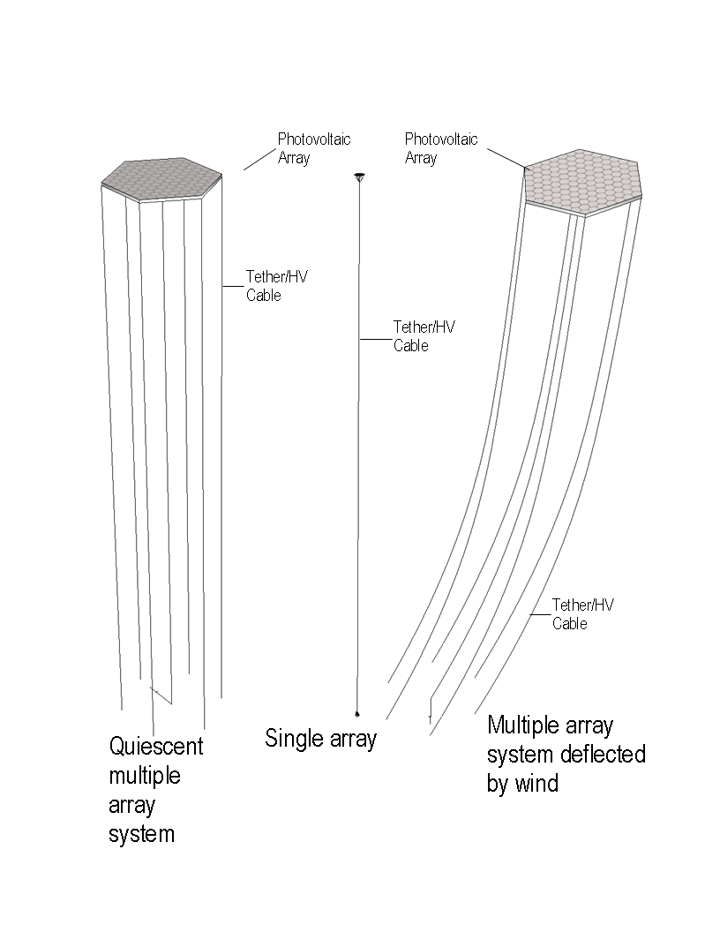

Figure

Figure 2 shows an individual PV system in the center. Figure 11 shows a close up view of the platform. The novel element of a StratoSolar power plant is a buoyant tethered platform supporting an array of PV panels floating in the stratosphere. The strong and light tether incorporates a HV power cable that transfers electric power to the ground. Excess buoyancy in the floating platform pre-tensions the tether and allows the platform to resist wind forces.

A rigid truss structure supports the PV array. Buoyancy is from gasbags within the truss framework. Models for the PV array power output are subject to simulation to a high degree of accuracy, with high confidence in the results. While the buoyant structure is novel, there is no new science, and existing engineering design tools are sufficient. The wind and buoyancy forces are well understood from an engineering perspective. There are detailed meteorological models and historical data to provide an accurate statistical profile of the wind and buoyancy forces on the structure and tether. The combination of accurate structural analysis and reliable meteorological data mean that structural viability can be determined to a high confidence level before construction. Accurate models for sunlight and how it varies with location and altitude, daily and seasonally, provide an equally high confidence level for the power output.

Figure 2 also shows two views of a large-scale system, the first view on the left with no wind and the second view on the right with a maximum wind load. The large-scale system is a collection of mechanically connected individual modular small-scale systems. For clarity only some of the tethers are shown. The benefits of connecting multiple smaller systems to make a larger system are reduced aerodynamic drag on the PV array and reduced impact on regulated airspace. The array is directionally stable and panels can track the sun. The reduced aerodynamic drag ensures that the structure can withstand the highest wind forces with a large safety margin and is safe to deploy on a permanent basis. It also facilitates modular maintenance and repair, technology upgrades, and incremental overall system expansion. Individual arrays can be winched down in a few hours when wind and weather permits and can use adjacent tethers as guides to ensure safe control.

Operationally there should be no need for people at 20km. There is no need for large “hanger” structures, either for construction or maintenance. During construction and maintenance the array structure is anchored at multiple points to the ground and effectively forms a roof over a protected space. Maintenance on the ground only occurs during good weather and at night to avoid disruption in power output. Plants can safely be raised and lowered in a few hours, and with close attention to weather, the window of exposure to unexpected weather is very small.

Another benefit of the modular approach is the system can grow and be financed incrementally, reducing the risk capital required to develop and demonstrate the system viability.

## Beyond electricity generation:

A permanent high altitude platform could serve many additional purposes. Listed below are some examples of possible uses.

* Communications and observation platform
  + Cell phone tower, data networks
  + Radar for weather, commercial, military
  + Science: astronomy, meteorology, earth science
  + Laser communications network
  + Tourism

## Solar energy available for selected locations at ground level and at 20km altitude

|  |  |  |  |  |  |  |  |
| --- | --- | --- | --- | --- | --- | --- | --- |
| **Latitude** | **Location** | **ground kWh/day** | **Utilization** | **20km kWh/day** | **Util** | **20km**  **2-axis kWh/day** | **Util** |
| 34.8 | Barstow | 5.77 | 24% | 8.55 | 36% | 16.38 | 68% |
| 37.7 | San Francisco | 4.76 | 20% | 7.70 | 32% | 15.74 | 66% |
| 34.7 | Osaka | 4.00 | 17% |  |  |  |  |
| 42.3 | Boston | 3.86 | 16% |  |  |  |  |
| 41.8 | Chicago | 3.62 | 15% | 7.37 | 31% | 15.10 | 63% |
| 46.8 | Quebec | 3.61 | 15% |  |  |  |  |
| 47.6 | Seattle | 3.23 | 13% |  |  |  |  |
| 48.7 | Stuttgart | 3.06 | 13% | 6.85 | 29% | 15.01 | 63% |
| 53.5 | Hamburg | 2.67 | 11% |  |  |  |  |
| 59.3 | Stockholm | 2.64 | 11% | 6.00 | 25% | 14.30 | 60% |
| 51.5 | London | 2.66 | 11% |  |  |  |  |
| 53.3 | Dublin | 2.30 | 10% |  |  |  |  |

Table Average daily solar energy kWh/m2 and associated utilization factor for selected locations

The ground columns in Table 1 show average daily kW.h per square meter of total sunlight for selected locations. This is real data gathered over many years by [NREL](http://rredc.nrel.gov/solar/old_data/nsrdb/redbook/atlas/) and others. The data shown is for flat plate horizontal collectors. The 20km columns show StratoSolar data for the selected latitudes generated using atmospheric models. (1) Simple StratoSolar systems will be horizontal flat plate. Varying degrees of tracking are possible, and real systems will have results intermediate between flat plate and 2-axis tracking. StratoSolar data points illustrate that the average daily kW.h diminishes slowly with increasing latitude at 20km altitude. This means that the power output from a StratoSolar PV system is fairly independent of geography, unlike ground based PV systems which as the table shows gather less energy per square meter at higher latitudes and are therefore significantly less cost effective. For example a simple flat plate StratoSolar system at latitude 60 has a higher utilization than the best surface system in the desert. For daily average kWh/m2 data (the most common data available), the PV utilization factor is simply the kWh/m2/day divided by 24. This utilization factor applies to PV panels or PV plants whose power is specified in peak Watts (Wp), the industry standard way PV power is rated. Peak Watts is the electricity output for a standard sunlight input of 1kW/m2. At 20km sunlight can exceed 1.3kW/m2, which explains utilizations that exceed the theoretical 50% maximum achievable on the ground.

## Behavior of systems under wind load:

The graphs in Figure 3 below show the results of simulations of a single module/tether and Figure 3 shows a 100-module PV array system with multiple tethers subjected maximum wind loads in the troposphere and the stratosphere. The vertical axis is altitude in kilometers. The horizontal axis is down-wind deflection in kilometers. The module design assumes the following parameters. The PV array radius is 175 m and depth is 94 m. The radius of the tether is 0.04 m. The large array is 100 of the modules mechanically joined to form a thin disk 3500m in diameter and 94m deep.

The 2D calculation models the tethers as 20 rigid segments connected by pin joints. The calculation is iterative. The wind force on each segment is calculated and depends on the angle of the tether and the altitude. It also depends on the coefficient of drag, wind velocity and air density. Weight for each segment is also calculated. The length of each tether segment lengthens to maintain the platform at 20km altitude and model the tethers “playing out” under wind load. The wind force for each segment changes with altitude and updates iteratively. The desired maximum deflection sets the required amount of buoyancy.

The top four graphs in Figure 3 show progressively stronger wind loads. Larger pictures are in the Appendix. The sequence from left to right is

1. average winds in the troposphere and the stratosphere
2. maximum winds in the troposphere, average wind in the stratosphere
3. average winds in the troposphere, maximum winds in the stratosphere
4. maximum winds in the troposphere, maximum winds in the stratosphere

Average winds are from NASA charts. Worst-case troposphere winds are from NASA and IGRA (2) (3). Worst-case stratospheric wind is from HAA research (4). The graphs show relatively small deflections due to troposphere winds exceeding hurricane force acting on the tethers. The winds in the stratosphere acting on the buoyant platform have the most influence on the maximum deflection of the platform. This shows that where the weather events with the greatest uncertainty occur, we have the biggest margin of safety. Even if the worst-case troposphere wind forces were several times larger than the worst case analyzed, there would be no risk of catastrophic failure.

The goal of the simulation is to verify the practicality and the cost of the solution. The quantities of two materials dominate the wind related costs; the polymer tether cables and hydrogen gas used for buoyancy. For the 360m platform simulation, 62 tonnes of polymer cables are required at $20/kg for a total of $1,245,165. The hydrogen required is 53 tonnes at $6/kg for a total of $319,000.

The graph in Figure 3 shows maximum troposphere and stratosphere winds acting on the large array. T This shows the aerodynamic scaling benefit of the large array. Deflection is smaller under worst-case stratospheric wind.



Figure Small 360m platform tether and PV array deflection under wind loads



Figure Large 3600m platform tethers and array deflection under maximum wind load

Accurate models for the aerodynamic behaviors of cylinders also allow the calculation of vortex-shedding induced forces (5)on the tether. These are high frequency and low amplitude. Asymmetric aerodynamics of a structure cause the more dangerous “galloping” forces. For example, asymmetric ice buildup causes galloping in the case of power cables.

This is a simple static model. It is possible, using engineering software tools, to simulate the system with an accurate meteorological wind model that then drives a simulation of the aerodynamic and dynamic behavior of the structure. This is one of the goals of the funded R&D stage. Accurate computer simulation can test and verify much of the risky engineering.

## Electricity cost for different locations and capital costs

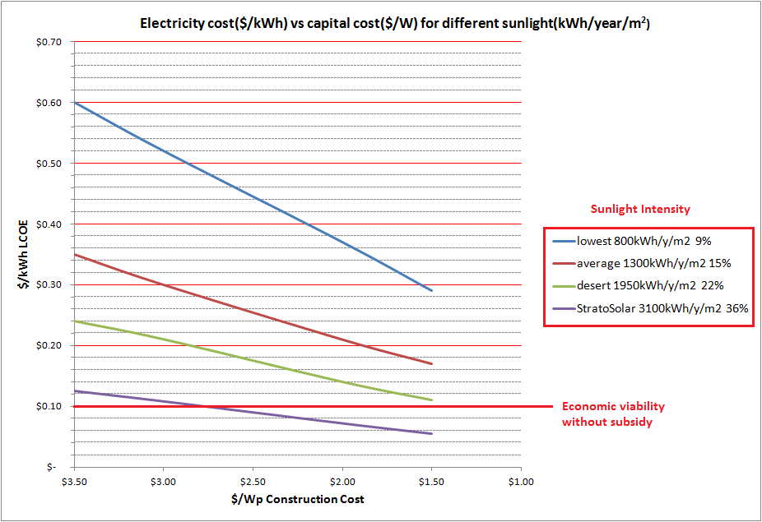

Figure PV electricity cost vs. capital cost for different utilization factors for different locations

Figure 5 shows the relationship between capital cost in $/Wp and the resulting levelized cost of electricity (LCOE) in $/kWh for varying sunlight at different geographic locations. It assumes a 20-year plant life, 8.5% working average cost of capital (WACC) and 2% of capital cost for annual operation and maintenance (O&M).

Lowest sunlight is northern Europe, desert is US southwest. Sunlight is in average kWh/m2/year. A common way to refer to this variability in power output is to convert it to a utilization or capacity factor percentage. This is useful when comparing different power plant technologies. Using this metric, lowest is about 9%, average is about 15%, desert is about 22%, and StratoSolar is about a 36% utilization factor.

Given an expected $/Wp construction cost and a location with known sunlight or its equivalent utilization factor(like Table 1), this chart shows the associated levelized cost of electricity (LCOE) in $/kWh. Displaying the information in this form graphically illustrates a number of important comparisons while only making assumptions concerning financing.

To understand the key points this chart illustrates it is useful to know that the 2010 average PV plant construction cost was $3.50/Wp, and the long term historical cost trend is reducing this cost to $1.50/Wp in the next ten to fifteen years.  
  
The horizontal line at $0.10/kWh represents electricity that is competitive in the marketplace without subsidy.  This is an extremely significant barrier to cross.  Above the line is the world of government subsidy politics and low volume.  Below the line is the world of market economics and high volume.

The vertical distance from this economic viability line to the different utilization lines represents the amount of subsidy needed. As can be seen the subsidy can be very large. This subsidy shows up in different ways. In Europe the mechanism is mostly feed-in tariffs that result in higher costs of electricity to consumers. In the US, the mechanism is mostly tax credits and accelerated depreciation ultimately paid by taxpayers.

This chart illustrates several points:

1. The same plant with the same capital cost produces electricity with highly variable cost depending on location. E.g. at the 2010, $3.50/W capital cost, northern Europe generates electricity for about $0.60/kWh, and StratoSolar generates electricity for $0.12/kWh. StratoSolar has the best location (which can be over northern Europe) and lowest cost.
2. The $3.50/Wp capital cost is approximately the 2010 cost. At historical rates of improvement, the $1.50/W cost may occur by 2020 at best. Even in the best desert locations, the resulting ground based PV electricity will still cost $0.12/kWh which will not be competitive without subsidy in 2020.
3. The amount of subsidy required over the next ten years to maintain the historical PV capacity growth rate will become economically difficult to sustain. The historical growth rate would imply 200GWp capacity requiring subsidy in 2020 before breakeven at 1000GWp by 2025.
4. StratoSolar will produce electricity without subsidy with current PV technology $/Wp capital costs and will benefit equally from the PV $/Wp improvement path, producing increasingly lower cost electricity.
5. StratoSolar can do this for northern climes.

Utility scale PV in the desert needs huge additional investment in electricity distribution and backup generation that is not factored into the normal PV $/Wp estimates for construction cost and also has environmental and political problems. This means the “desert” trend line in the chart that appears closest to economic viability, is likely too optimistic.

This chart helps illustrate how far currently ground PV is from commercial viability and hints at the enormous cost of subsidy it will take globally to sustain the historical rate of improvement necessary. StratoSolar represents a low cost way to leverage the historical investment in PV technology into commercial viability at locations where PV is unlikely ever to be commercially viable and with today’s PV capital cost in $/Wp, which will apply even if the historical rate of $/Wp improvement slows.

## Cost of Subsidy:

The historical rate of PV plant cost reduction has been approximately 20% for each doubling in capacity manufactured and installed. Figure 6 below shows a projection of this trend forward at current rates until 2027. The future will not unfold as predictably as this graph would imply, but it does give a general sense of the magnitude of things. This rate of improvement from the current cost base will produce a growing and unsustainable subsidy burden as the GWp capacity rises exponentially while the cost of electricity does not fall below $0.10/kWh until around 2025. The implication is 200GWp capacity needing subsidy by 2020 before breakeven at 1000GWp capacity in 2025. Figure 7 below illustrates the growth and magnitude of the implied subsidy which adds up to a total of about $250B over about 15 years. If the political will to provide the subsidies that sustain the capacity growth diminishes, then the improvement in the $/Wp capital costs will slow and the unsubsidized market viability of PV will be delayed beyond 2025.

StratoSolar can quickly reduce or eliminate the cost of subsidy and thereby ensure the growth in volume of GWp capacity that will maintain or even increase the rate of cost improvement in PV technology. Getting to economic viability sooner with StratoSolar means the cost of the subsidy is greatly reduced, or given the unlikelihood of sustaining the subsidy, StratoSolar can ensure that historical growth in PV volume will not decline.

Figure PV system cost and volume projection to 2027

Figure PV subsidy cost projection to 2026

## Frequently asked questions:

### Question: How do you handle static electricity and lightning?

The cable outer protective polymer layer is slightly conductive to bleed charge to a grounded co-axial shield which also serves as the conductor for lightning strikes. Current aerostat cables scaled up to about 10cm in diameter serve as the basis of one possible StratoSolar cable design.

For some detail I would refer you to US patent 4842221 “Lightning hardened tether cable and an aerostat tethered to a mooring system therewith” (1989). This discusses the design of tethers associated with the high altitude radar aerostats that have been used by the Air Force since the seventies. These have exceeded altitudes of 10km. See also the TCOM web site <http://www.tcomlp.com/>.

Using an aluminum metal strut based rigid truss for the buoyant structure is in part motivated by having a grounded conductive frame to simplify solutions for static electricity and lightning protection. Similarly the use of metallic film coated plastics for gasbags as well as providing low leakage gas containment also provides conveniently grounded surfaces to avoid static buildup. The PV structure is well above thunderclouds, but lightning up strokes occur, and a rare form of up strokes called “Blue jets” are a recent area of investigation. The outer surfaces of the PV array structure will incorporate lightning arrestors, much like current high altitude aerostats.

### Question: How do you handle hydrogen safety?

Given the need for hydrogen as the buoyancy gas, a great deal of engineering is devoted to alleviating concerns about fire. This topic could fill several books, so I can only touch on it briefly. A fire requires hydrogen gas leakage, confinement of a hydrogen-air mixture, and an ignition source. Prevention focuses on avoiding these three conditions. Ventilation, inert gas boundary bags, and the static electricity, lightning protection and electrical distribution system safety systems provide a first layer of defense. Also all materials used are non-flammable. Hydrogen dissipates rapidly so ensuring it can do so starves any fire. Active measures include instrumentation to detect hydrogen and fire, emergency hydrogen venting systems and active fire suppression systems using inert gas. Hydrogen is a widely used material with a large body of safe engineering practice and hydrogen economy advocates have discussed its inherent safety attributes. For example see <http://www.rmi.org/rmi/Library%2FE03-05_TwentyHydrogenMyths> . The Hindenburg is usually cited as the classic example of the dangers of hydrogen, but even to this day controversy surrounds the cause of the fire, and in rigid airships as a whole, fire was not the dominant cause of destruction or loss of life.

### Question: Is station keeping an alternative to tethering?

Station keeping is difficult. High altitude station keeping airships powered by PV arrays and batteries have been investigated for a decade or more, and teeter on the edge of practicality. See the HAA stratospheric winds paper reference in the bibliography section on the StratoSolar web site. Basically, the highest occasional stratospheric winds that come from excursions of the polar vortex can get to 40m/s. Countering this wind requires a very large motor thrust. It also needs to work at night when power would have to come from batteries that weigh a lot, cost a lot, and don’t have a very long life. At very large scale (several kilometers in diameter), a thin aerodynamic disk collector might be able to station keep. The cost of motors and batteries, the power loss needed for thrust, the over 50% loss due to microwave conversion at both ends and atmospheric attenuation in between, and the cost of the rectenna array on the ground would all add up to make it way too expensive compared to a simple tethered array.

### Question: Will the FAA and other airspace regulators have jurisdiction?

The FAA would clearly have concerns. Compared to various proposals to harness wind power from the jet stream using enormous numbers of windmills, the StratoSolar impact on airspace would be minimal. StratoSolar relies on a few large systems, probably placed in groups away from air traffic corridors. It would have little impact on commercial aviation which already deals with a complex air traffic control system. The PV array structures are well above the cruising altitude of aircraft, so the danger is from the tethers. It is possible to conceive of safety systems mounted on the PV arrays that actively track possible aircraft impact on tethers and automatically sever the tether to avoid impact. This could be done in a controlled way at connectors spaced periodically along the tethers. The redundancy provided by many tethers would make this possible. California might need 30 systems overall, probably in two groups, one near LA, and one near the bay area to satisfy all its daylight electricity needs. If commercially viable electrical energy storage becomes viable, additional StratoSolar systems could satisfy more of our energy needs boosting the number of systems. On the other hand, improved PV efficiencies could reduce the number of systems.

### Question: Will financing and insurance be difficult to obtain?

As stated in the opening blog posting, the StratoSolar-PV alternative is the result of studying the concerns raised by the original CSP based design which was perceived to be too risky on several fronts.

* The risk of catastrophic loss from extreme weather events
* The complexity of developing many technologies at untested scales and new environments
* The complexity of needing many costly and risky elements to build a system
* The inability to demonstrate and develop a system on a small scale

The PV system attacks these concerns directly. The design reduces catastrophic risks, has many fewer technology development elements, has very few elements to build a system, and provides incremental engineering development and incremental system deployment starting from a much lower initial cost in order to reduce financial risk at each stage.

Catastrophic risks are reduced by reducing the wind loads on the tethers and the PV array platform to where the system can sustain winds beyond worst case known winds simultaneously at all altitudes. The tethers have a very low cross section, and the platform is horizontal with a low cross section and static with no moving parts.

The development can start with a small R&D engineering test platform and simple tether that will cost in the low millions of dollars. This gets across the psychological barrier of actually tethering something useful at 20km altitude. It also develops and tests all the platform structural and electrical elements.

The 10MW power platform will cost tens of millions of dollars. This expenditure will be incremental in nature.

Finance and Insurance costs depend on the risks and the rewards. Unlike nuclear power, liability insurance should be low. Understanding the probabilities of damaging or destructive events will only come with time and experience. The R&D process should provide a degree of confidence as it progresses over several years and the technology becomes familiar. A successful R&D program that results in a product that demonstrates competitive economics for solar power will be a powerful incentive to overcome what should by then be imagined risks. The first systems will be relatively small investments. If the market finds it too difficult to fund or insure the early deployment stage, it is reasonable to expect that government assistance perhaps in the form of loan guarantees will fill that gap. Governments currently seem happiest supporting alternative energy at the early deployment stage.

### Question: How will you survive extreme weather events like thunderstorms and hurricanes?

Extreme weather events occur in the troposphere. The PV platforms are safely above the troposphere, so only the tethers suffer from weather extremes like hurricanes. The tethers have a small cross section and the forces resulting from extreme winds only result in small deflections. See the PV article or the PV tutorial document wind sections that discuss the worst-case wind forces on the tether and PV platform in detail.

### Question: Will icing on the tether be a problem?

Possibly. Icing occurs in the troposphere where tethered aerostats have been deployed for many decades. Icing has not been a documented problem for these aerostats or tethers. Should it become an issue there are several engineering solutions to help prevent it.

### Question: Won’t the structure be vulnerable during deployment?

It will be important to monitor weather and wind before deployment, much like deploying a large oil production platform today. However the window of exposure is very small. Systems can be deployed in less than two hours. Modern technology can monitor and predict weather with sufficient accuracy that a two-hour window can be guaranteed with a very high degree of confidence.

### Question: How will you handle maintenance and repair?

The systems are designed with a high degree of redundancy. Failure of individual components will result in small losses of power output. It is envisaged that systems will be winched down perhaps once per year to repair or replace the accumulated failed components. As with deployment, the window of exposure to bad weather is very small and systems will be brought down only when risks are minimal.

### Question: How will you handle construction and deployment?

See the video

### Question: Won’t the large-scale structures cast a large shadow?

While the structures are large they are small compared to clouds and are much higher than most clouds. The shadow footprint on the ground is small and transient as the earth rotates. See the animations on the web site to get a visual appreciation of the scale.

### Question: What will be the consequences if a structure loses buoyancy and falls from the sky?

The platform structures are very lightweight for their size. For a structure to fall it must lose most of its buoyancy gas, either through fire or structural collapse, or a mixture of both. Almost all scenarios would result in debris falling on a lightly populated location close to the tether anchor. This combination of low-density material falling in a lightly populated area would result in very little collateral damage.

### Question: How will you handle hydrogen leakage and air contamination?

The rate of hydrogen loss from gasbags is very low, less than 1% a year, so a small diameter low-pressure hose would suffice to replace leakage which would be at most a few kilograms a day for a 10MWp platform. Contamination from air infiltration is an unlikely issue for gasbags as there is no pressure gradient from ballonets to drive air inward. The simplest technical solution would be to replace leakage losses during routine maintenance on the ground.

List of abbreviations:

PV Photovoltaic

DNSI Direct Normal Solar Insolation

CSP Concentrated Solar Power

CPC Compound Parabolic Concentrator

kWh kilo Watt hours

GWe Giga Watt electrical

Pa Pascal

MPa Mega Pascal

PPA Power Purchase Agreement

ppm part per million

PET Polyethylene Terephthalate

mrad milli radian

LEC Levelized Electricity Cost

O&M Operation and Maintenance

R&D Research and Development

WACC Working Average Cost of Capital

OLF Optical Light Film

Wh Watt hours

HAA High Altitude Airship

UV Ultra Violet

UHMWPE Ultra-high-molecular-weight polyethylene

LCOE Levelized cost of electricity

Wp Peak Watts, a standard measure of PV panel power output

## Bibliography

1. *Parameterized transmittance model for direct beam and circumsolar spectral irradiance.* **Gueymard, Christian A.** 2001, Solar energy, pp. 325, 346.

2. *Enhanced radiosonde data for studies of vertical structure.* **Imke Durre, Xungang Yin.** 2008, BAMS, pp. 1257-1262.

3. *Air mass and refraction.* **Young, A. T.** s.l. : Applied Optics. 33:1108–1110, 1991, Vol. 33, pp. 1108–1110.

4. *POST: A stratospheric telescope for the Antartic.* **Michael A. Dopita, Holland C. Ford, John Bally, Pierre Bely.** 13, s.l. : Astron. Soc. Aust., 1996, Astron. Soc. Aust., pp. 48-59.

5. **E. Onate, B. Kroplin.** *Textile composites and inflatable structures II.* s.l. : Springer, 2008. ISBN 978-1-4020-6855-3.

6. **Tiwari, G.N.** *Solar energy.* s.l. : Alpha science international inc., 2002. ISBN 978-1-84265-106-3.

7. **John A. Duffie, William A. Beckman.** *Solar Engineering of thermal processes.* s.l. : John Wiley and sons, Inc.,, 2006. ISBN-13 978-0-471-69867-8.

8. **Holms, John D.** *Wind loading of structures.* s.l. : Taylor and Francis, 2001. ISBN10: 0-415-40946-2.

9. *Desalination: present and future.* **Semiat, Raphael.** s.l. : Water International, 2000, Vol. 25, pp. 54-65.

10. **George A. Olah, Alain Goeppert, G. K. Prakash.** *Beyond oil and gas: the methanol economy.* s.l. : Wiley-VCH, 2006. ISBN-13: 978-3-527-31275-7.

11. **Imke Durre, Russell S. Vose, David B. Wuertz.** *Overview of the Integrated Global Radiosonde Archive.* Asheville, NC : National Cimatic Data Center, 2006.

12. **D. M. Smith, W. Goodwin, J. A. Schillinger.** *Challanges to the worldwide supply of helium in the next decade.* Allentown, PA : Air Products and Chemicals Inc., 2002.

13. **Lovins, Amory B.** *20 Hydrogen myths.* s.l. : Rocky Mountain Institute, 2005.

14. TCOM home page. *TCOM.* [Online] 2010. http://www.tcomlp.com/aerostats.html.

15. **Jonathan M. Ross.** *A Practical Approach for Ship Construction Cost Estimating.* s.l. : Proteus Engineering, Anteon Corporation, U.S.A., jross@anteon.com, 2004.

16. **Ursula Murschall, Ulrich kern, Andreas Stopp, Guenther Crass.** *Transparent, UV resistant,thermoformable film made from crystallizable thermoplastics, and process for its production. 6,902,818 B2* USA, 2005.

17. **George D. Modica, Thomas Nehrkom, Thomas Myers.** *An investigation of stratospheric winds in support of the high altitude airship.* Lexington, MA : Atmospheric and environmental research Inc., 2006.

Appendix

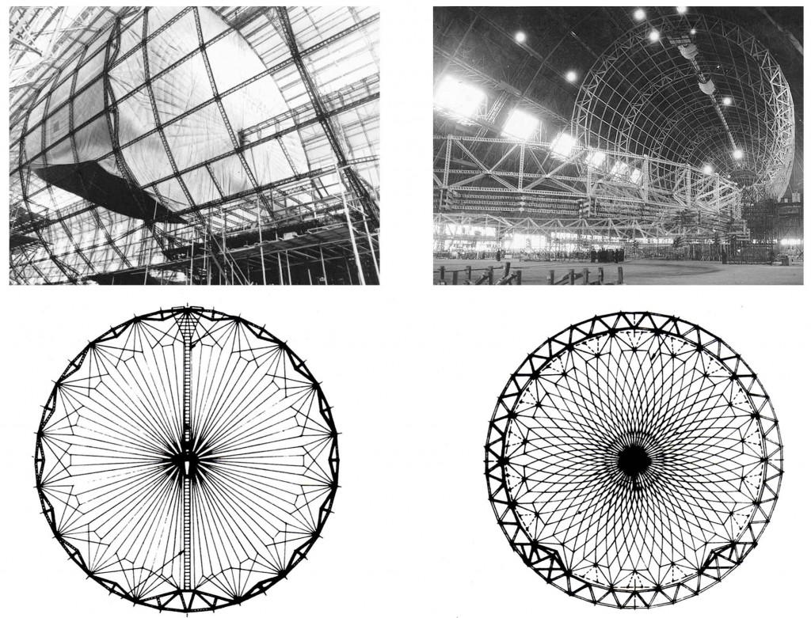

Figure 8 Internal structure of the Hindenburg and the Macon

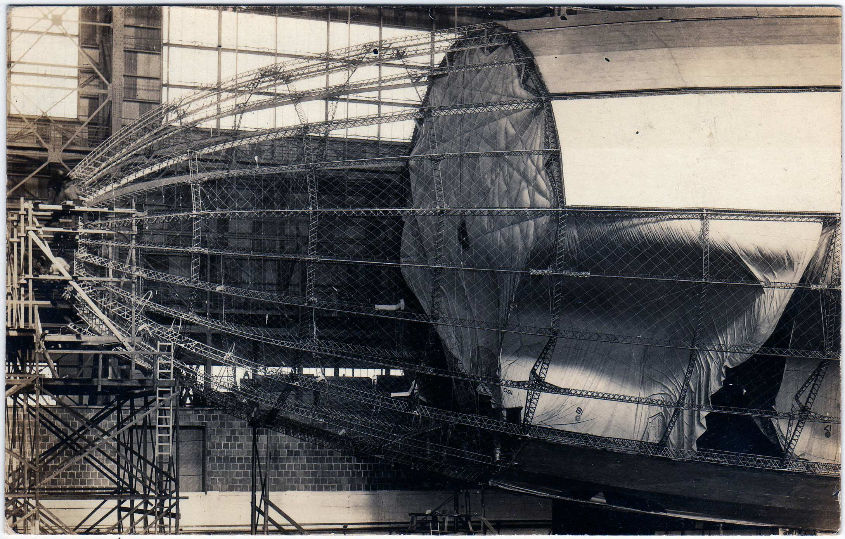

Figure Internal structure of the Shenandoah

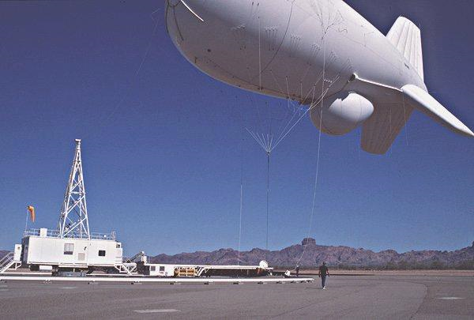

Figure Air force tethered aerostat radar

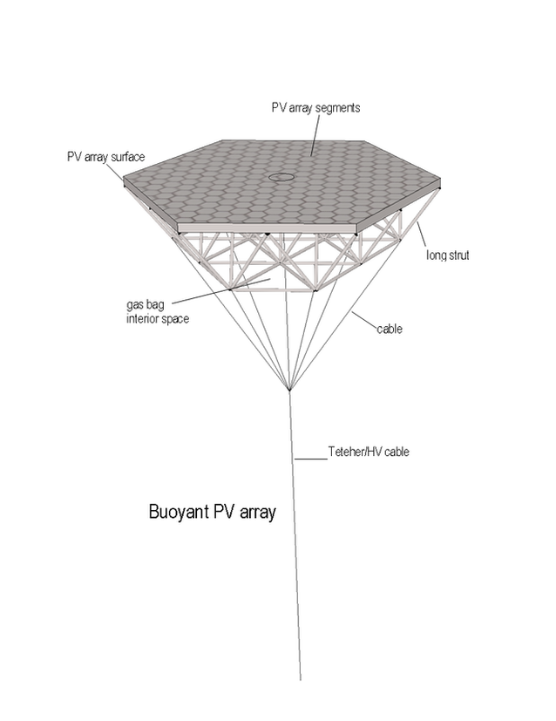

Figure 360m buoyant PV array

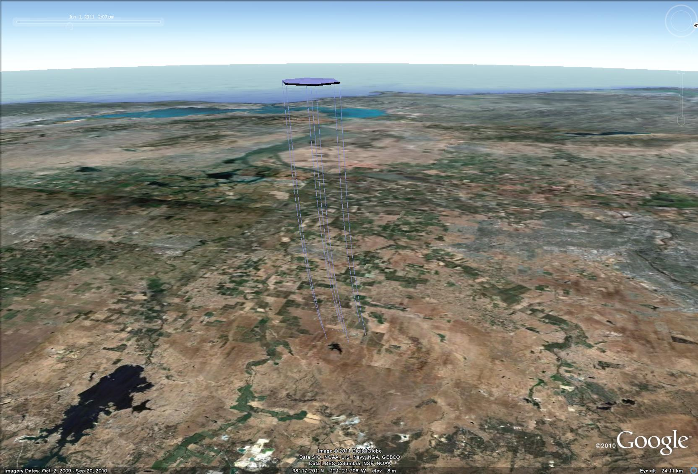

Figure View of a 3,600m PV array from a high-flying aircraft

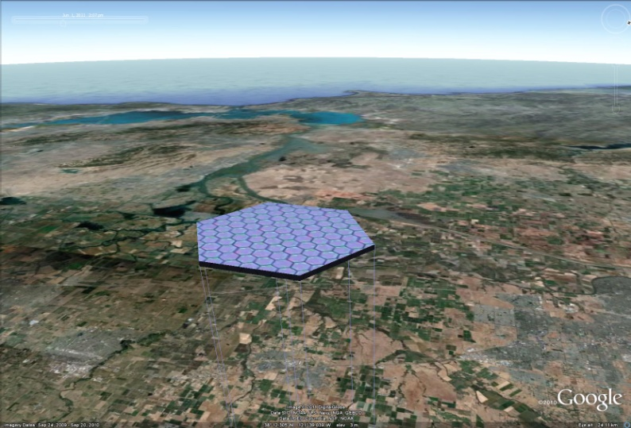

Figure View of a 3,600m PV array from a high-flying aircraft

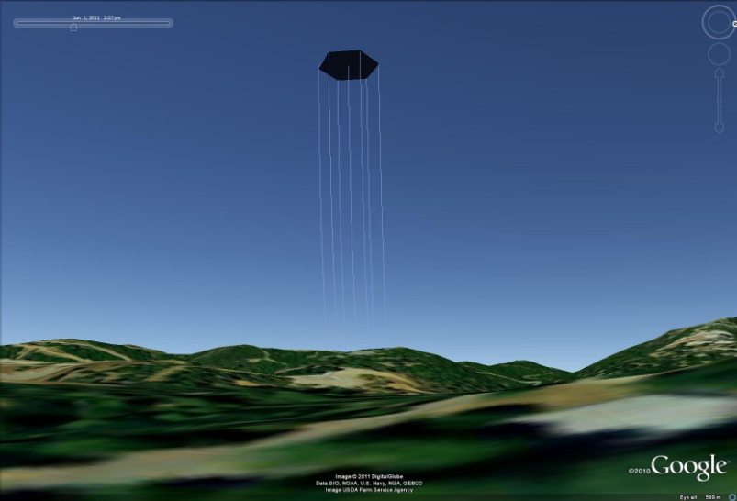

Figure View of a 3,600m PV array from 10km

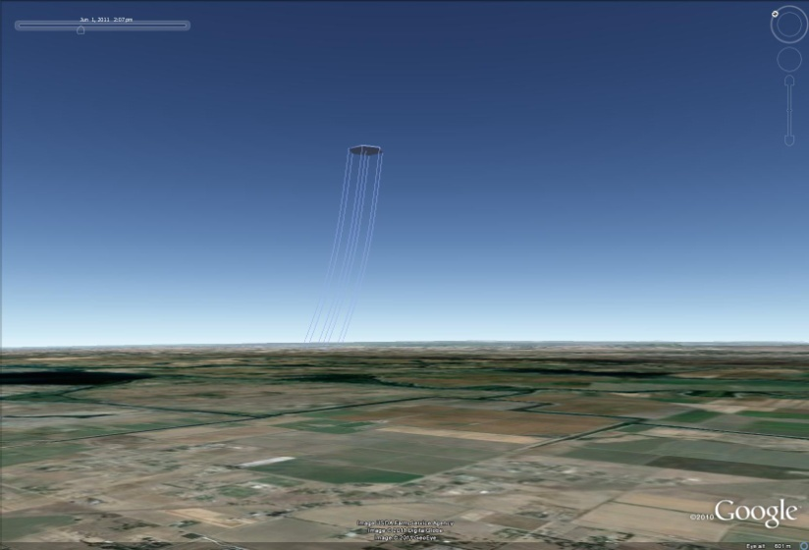

Figure View of a 3,600m PV array from 100km

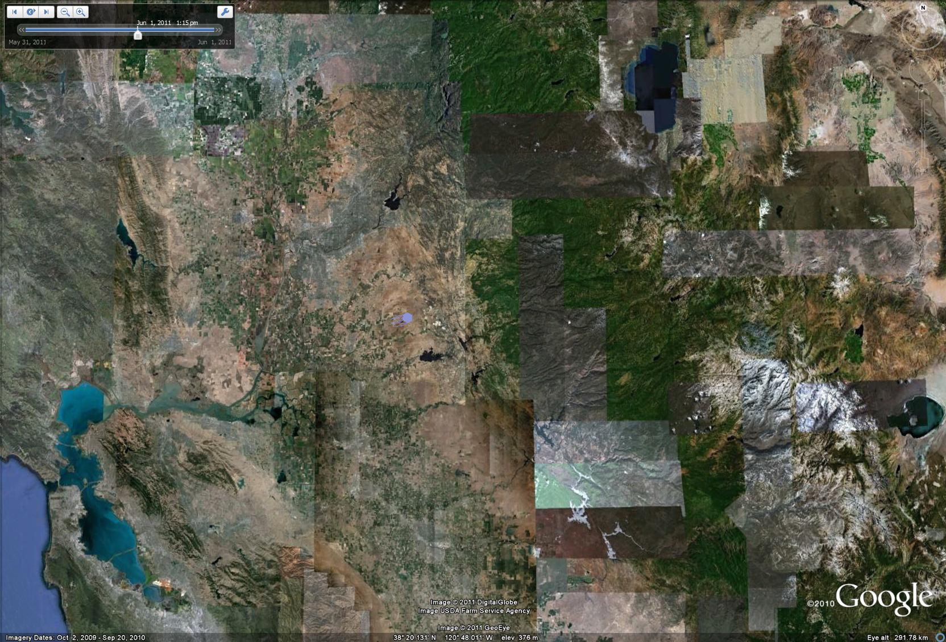

Figure View of a 3,600m PV array from low earth orbit



Figure Small 360m tether and platform deflection for average wind on the tether and average wind on the platform



Figure Small 360m tether and platform deflection for maximum wind on the tether and average wind on the platform



Figure Small 360m tether and platform deflection for average winds on the tether and maximum wind on the platform



Figure Small 360m tether and platform deflection for maximum wind on the tether and maximum wind on the platform



Figure Large 3600m tether and platform deflection for maximum wind on the tether and maximum wind on the platform